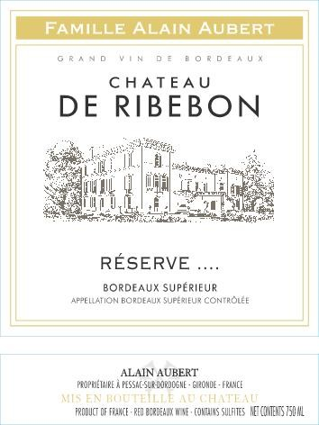

**CHÂTEAU DE RIBEBON RÉSERVE**

**« Bordeaux Supérieur »**

Château de Ribebon’s 2016 “Réserve” growing season experienced a wet spring followed by a very dry and warm summer. The cool, sunny weather allowed for incredible ripeness of the grapes. 2016 is a year of purity, freshness as well as a classic style of Bordeaux.

On Bordeaux’s Right Bank, overlooking the Dordogne River and the village of Pessac-sur-Dordogne, the clay-limestone soils of the Ribebon hamlet plateau form the basis of Château de Ribebon RÉSERVE Bordeaux Supérieur. The vines have a full southern sun exposure, allowing for maximum sun to help bring the fruit to full ripeness. The plateau’s clay and limestone soils offer nutritional balance and allow the vines to adapt to climatic variation.

The old Cabernet Franc vines thrive in this limestone plateau as it is expressed in the wine as a refined elegance and sophistication. The Merlot is completely in its element in the clay soils, showing in the wine as exalted, rich fruit and a poised counterpoint to the structure and tannins of Cabernet Sauvignon. This tannic structure is at the same time rendered more subtle and delicate by the limestone. Oak-aged for +/- 18 months, this wine is the quintessential marriage of elegance and balance.

The Alain Aubert family come from the winemaking tradition of Bordeaux’s Right Bank. For several decades now, Alain, his wife Bernadette, and their three daughters have fine-tuned and perfected their craft. To celebrate their achievements, their US importer and close friend, Serge Doré, collaborated to create this special and exclusive set of new labels and wines, all proudly bearing the “Famille Alain Aubert” banner across the top to honor the work of the family.

ORIGIN

Bordeaux, France

APPELLATION

AOC Bordeaux Supérieur

VINEYARD

60 yrs. old vines on average, with some that are over 100 yrs. old

Limestone & clay soil

Yield: 35 hl/ha

BLEND

50% Merlot, 30% Cabernet Sauvignon, 20% Cabernet Franc

FARMING

Hand harvested and destemmed in field

WINEMAKING

4 – 5 days of Fermentation

20 – 25 days of Maceration

AGING

Oak-aged for +/- 18 months

TECHNICAL INFORMATION

13.5% Alc. |

FOOD PAIRING

Enjoy with grilled meats such as beef, duck, venison, etc.

ACCOLADES

2016 International Wine Report – 92 points

*“The 2016 Bordeaux Supérieur 'Reserve' from Château Ribebon is composed of 50% Merlot, 30% Cabernet Sauvignon and 20% Cabernet Franc. It is an excellent showing in in this vintage, offering aromas of ripe cherries and blackberries laced with spring florals, tobacco, toast and exotic spices all coming together in the glass. On the palate this is medium-bodied and nicely structured with velvety tannins that lead into the long, refined finish…”*